EXPERIMENTS
NAME:S Surender
REG NO:1924260070
COURSE CODE:DSA0601 DATA HANDLING AND
VISUALIZATION
SET 9 – ONLINE LEARNING ACTIVITY ANALYSIS
Student_I  D | Gende  r | Ag  e | Cours  e | Study_Ti me (hrs) | Videos_Watch  ed | Quiz_Scor  e | Login_Dat  e
L01 | Male | 20 | R | 3.5 | 12 | 78 | 2025-01-05
L02 | Female | 22 | R | 4.2 | 15 | 85 | 2025-01-05
L03 | Male | 19 | SQL | 2.0 | 8 | 65 | 2025-02-08
L04 | Female | 21 | R | 5.0 | 18 | 92 | 2025-02-08
L05 | Male | 23 | R | 2.5 | 9 | 70 | 2025-03-12
L06 | Female | 20 | SQL | 4.0 | 14 | 88 | 2025-03-12
Import the dataset in R. Plot a histogram for Quiz_Score. Draw a boxplot of
Quiz_Score by Course. Add title and labels. Interpret student performance.
AIM
To analyze the distribution of quiz scores using a histogram and compare quiz scores
across different courses using a boxplot.
PROCEDURE
1. Create or import the Online Learning Activity dataset.
2. Store the student information in R.
3. Plot a histogram for Quiz_Score.
4. Plot a boxplot of Quiz_Score by Course.
5. Add suitable titles and labels.
6. Interpret the student performance.
CODE


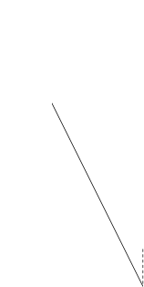
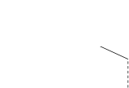

data <- data.frame(
Student_ID = c("L01","L02","L03","L04","L05","L06"),
Gender = c("Male","Female","Male","Female","Male","Female"),
Age = c(20,22,19,21,23,20),
Course = c("R","R","SQL","R","R","SQL"),
Study_Time = c(3.5,4.2,2.0,5.0,2.5,4.0),
Videos_Watched = c(12,15,8,18,9,14),
Quiz_Score = c(78,85,65,92,70,88),
Login_Date = c("2025-01-05","2025-01-05","2025-02-08",
"2025-02-08","2025-03-12","2025-03-12")
)
hist(
data$Quiz_Score,
main = "Distribution of Quiz Scores",
xlab = "Quiz Score",
ylab = "Frequency"
)
boxplot(
Quiz_Score ~ Course,
data = data,
main = "Quiz Score by Course",
xlab = "Course",
ylab = "Quiz Score"
)
OUTPUT
Quiz Score by Course
R SQL
Course
RESULT

Thus, the histogram and boxplot were successfully created and student quiz
performance was analyzed.
QUESTION 2
Create a scatter plot using R programming between Study_Time and
Quiz_Score. Represent Videos_Watched using bubble size. Apply transparency.
Explain the learning pattern.
AIM
To analyze the relationship between study time and quiz score using a bubble scatter
plot.
PROCEDURE
1. Create the online learning dataset.
2. Use Study_Time on the X-axis.
3. Use Quiz_Score on the Y-axis.
4. Represent Videos_Watched using bubble size.
5. Apply transparency to the bubbles.
6. Add title and axis labels.
7. Interpret the learning pattern
CODE
data <- data.frame(
Student_ID = c("L01","L02","L03","L04","L05","L06"),
Gender = c("Male","Female","Male","Female","Male","Female"),
Age = c(20,22,19,21,23,20),
Course = c("R","R","SQL","R","R","SQL"),
Study_Time = c(3.5,4.2,2.0,5.0,2.5,4.0),
Videos_Watched = c(12,15,8,18,9,14),
Quiz_Score = c(78,85,65,92,70,88)
)
symbols(
data$Study_Time,
data$Quiz_Score,
circles = data$Videos_Watched,
inches = 0.4,
bg = adjustcolor("blue", alpha.f = 0.4),
fg = "blue",






xlab = "Study Time (hours)",
ylab = "Quiz Score",
main = "Study Time vs Quiz Score"
)
OUTPUT
Study Time vs Quiz Score

2.0 | 2.5 | 3.0 | 3.5 | 4.0 | 4.5 | 5.0
Study Time (hours)
RESULT
Thus, the relationship between study time, videos watched and quiz score was
successfully visualized using a bubble scatter plot.
QUESTION 3
Using R programming, convert Login_Date into Date format. Calculate average
quiz score per month. Plot a line chart. Apply moving average smoothing.
Identify the trend.
AIM
To analyze the monthly average quiz score and identify the performance trend using a
moving average line.
PROCEDURE
1. Create the online learning dataset.
2. Convert Login_Date into Date format using as.Date().
3. Extract the month from the login date.
4. Calculate the average quiz score for each month.
5. Calculate a moving average.
6. Plot the monthly average score as a line chart.
7. Add the moving average line.

8. Identify the trend.
CODE
data <- data.frame(
Student_ID = c("L01","L02","L03","L04","L05","L06"),
Gender = c("Male","Female","Male","Female","Male","Female"),
Age = c(20,22,19,21,23,20),
Course = c("R","R","SQL","R","R","SQL"),
Study_Time = c(3.5,4.2,2.0,5.0,2.5,4.0),
Videos_Watched = c(12,15,8,18,9,14),
Quiz_Score = c(78,85,65,92,70,88),
Login_Date = c("2025-01-05","2025-01-05","2025-02-08",
"2025-02-08","2025-03-12","2025-03-12")
)
data$Login_Date <- as.Date(data$Login_Date)
data$Month <- format(data$Login_Date, "%Y-%m")
monthly_avg <- aggregate(
Quiz_Score ~ Month,
data = data,
FUN = mean
)
monthly_avg$Moving_Average <- stats::filter(
monthly_avg$Quiz_Score,
rep(1/2, 2),
sides = 1
)
plot(
1:nrow(monthly_avg),
monthly_avg$Quiz_Score,
type = "o",
xlab = "Month",
ylab = "Average Quiz Score",
main = "Monthly Average Quiz Score",
xaxt = "n"
)
axis(
1,
at = 1:nrow(monthly_avg),
labels = monthly_avg$Month
)
lines(
1:nrow(monthly_avg),




monthly_avg$Moving_Average,
type = "o"
)
legend(
"topleft",
legend = c("Average Quiz Score", "Moving Average"),
lty = 1,
pch = 1
)
OUTPUT
Monthly Average Quiz Score
Average Quiz Score
Moving Average
2025-01 | 2025-02 | 2025-03
Month
RESULT
Thus, the login dates were converted into Date format, monthly average quiz scores
were calculated, and the trend was successfully visualized using a line chart with
moving average smoothing.
QUESTION 4
Import Online_Learning_Activity.csv into Tableau. Create a bar chart showing
average quiz score by Course. Create a scatter plot (Study Time vs Quiz Score).
Add filter for Gender and Course. Design a mini interactive dashboard.

AIM
AIM
To create an interactive online learning activity dashboard using R programming with
a bar chart, scatter plot, and filters for Gender and Course.
PROCEDURE
1. Create the Online Learning Activity dataset.
2. Load the shiny package.
3. Create a bar chart for average quiz score by course.
4. Create a scatter plot between Study Time and Quiz Score.
5. Represent Videos Watched using bubble size.
6. Add Gender and Course filters.
7. Display the charts and student data in an interactive dashboard.
8. Run the Shiny application.
CODE
library(shiny)
data <- data.frame(
Student_ID = c("L01","L02","L03","L04","L05","L06"),
Gender = c("Male","Female","Male","Female","Male","Female"),
Age = c(20,22,19,21,23,20),
Course = c("R","R","SQL","R","R","SQL"),
Study_Time = c(3.5,4.2,2.0,5.0,2.5,4.0),
Videos_Watched = c(12,15,8,18,9,14),
Quiz_Score = c(78,85,65,92,70,88),
Login_Date = c("2025-01-05","2025-01-05","2025-02-08",
"2025-02-08","2025-03-12","2025-03-12")
)
ui <- fluidPage(
titlePanel("Online Learning Activity Dashboard"),
sidebarLayout(
sidebarPanel(
selectInput(
"gender",
"Select Gender:",
choices = c("All", "Male", "Female")
),
selectInput(
"course",
"Select Course:",
choices = c("All", "R", "SQL")

)
),
mainPanel(
plotOutput("barPlot"),
plotOutput("scatterPlot"),
tableOutput("dataTable")
)
)
)
server <- function(input, output) {
filteredData <- reactive({
result <- data
if (input$gender != "All") {
result <- result[result$Gender == input$gender, ]
}
if (input$course != "All") {
result <- result[result$Course == input$course, ]
}
result
})
output$barPlot <- renderPlot({
result <- filteredData()
avg_score <- aggregate(
Quiz_Score ~ Course,
data = result,
FUN = mean
)
barplot(
avg_score$Quiz_Score,
names.arg = avg_score$Course,
xlab = "Course",
ylab = "Average Quiz Score",
main = "Average Quiz Score by Course"
)
})
output$scatterPlot <- renderPlot({
result <- filteredData()

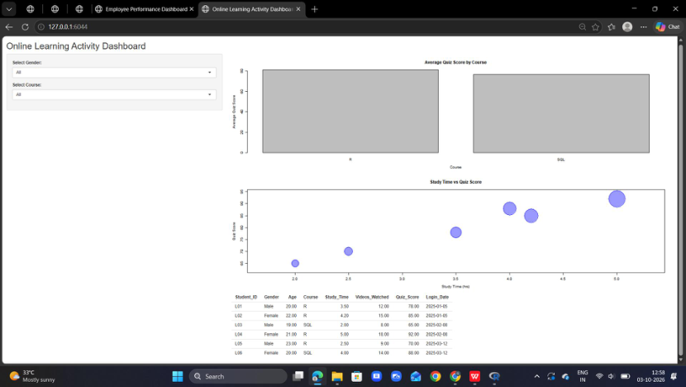

symbols(
result$Study_Time,
result$Quiz_Score,
circles = result$Videos_Watched,
inches = 0.4,
bg = adjustcolor("blue", alpha.f = 0.4),
fg = "blue",
xlab = "Study Time (hrs)",
ylab = "Quiz Score",
main = "Study Time vs Quiz Score"
)
})
output$dataTable <- renderTable({
filteredData()
})
}
shinyApp(ui = ui, server = server)
OUTPUT
RESULT
Thus, an interactive Online Learning Activity Dashboard containing the average
quiz score bar chart, study-time scatter plot, filters and data table was successfully
created using R Shiny.

